****"CRC****
Error
A condition when the receiver’s information does not matches with the sender’s information. During transmission, digital signals suffer from noise that can introduce errors in the binary bits travelling from sender to receiver. That means a 0 bit may change to 1 or a 1 bit may change to 0.
Error Detecting Codes (Implemented either at Data link layer or Transport Layer of OSI Model)
Whenever a message is transmitted, it may get scrambled by noise or data may get corrupted. To avoid this, we use error-detecting codes which are additional data added to a given digital message to help us detect if any error has occurred during transmission of the message.
Basic approach used for error detection is the use of redundancy bits, where additional bits are added to facilitate detection of errors.
Some popular techniques for error detection are:
1. Simple Parity check
2. Two-dimensional Parity check
3. Checksum
4. Cyclic redundancy check
Cyclic redundancy check (CRC)
Unlike checksum scheme, which is based on addition, CRC is based on binary division.
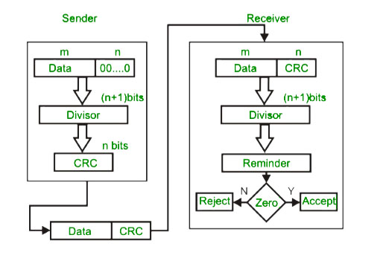
In CRC, a sequence of redundant bits, called cyclic redundancy check bits, are appended to the end of data unit so that the resulting data unit becomes exactly divisible by a second, predetermined binary numberAt the destination, the incoming data unit is divided by the same number. If at this step there is no remainder, the data unit is assumed to be correct and is therefore accepted.
A remainder indicates that the data unit has been damaged in transit and therefore must be rejected.
Example
